# 

# Gerrit and Git Setup on Local Machine

*By Danny Lenhof*

*6/17/2013*

*Updated: 11/27/2013*

**The purpose of this document is to outline the steps for the ESS Development Team to setup Gerrit and Git on their local machines.**

**The 6 steps for setup on local machine identified below.**

**1) Access Gerrit via http**

**2) Install TortoiseGit**

**3) Git setup with TortoiseGit**

**4) Copy the SSH Public Key into Gerrit**

**5) Use TortoiseGit to clone project from Git repository**

**6) From the command-line**

**NOTE: This document only covers the basics to install and configure Git and Gerrit on your local machine.**

1. **Access Gerrit via http**

Open the browser to <http://qmvm-pas-ubuntu.quadramed.com:8080>

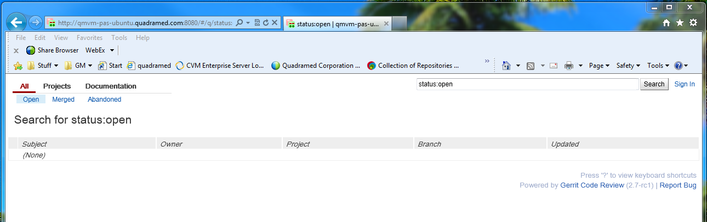

Gerrit is setup for LDAP - sign-in using your QuadraMed LDAP credentials. Click Sign In in the upper right.

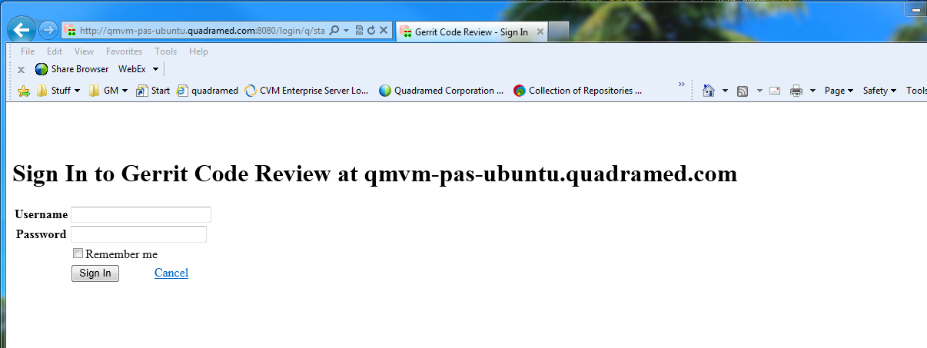

After sign-in, you will see your name in the upper right corner.

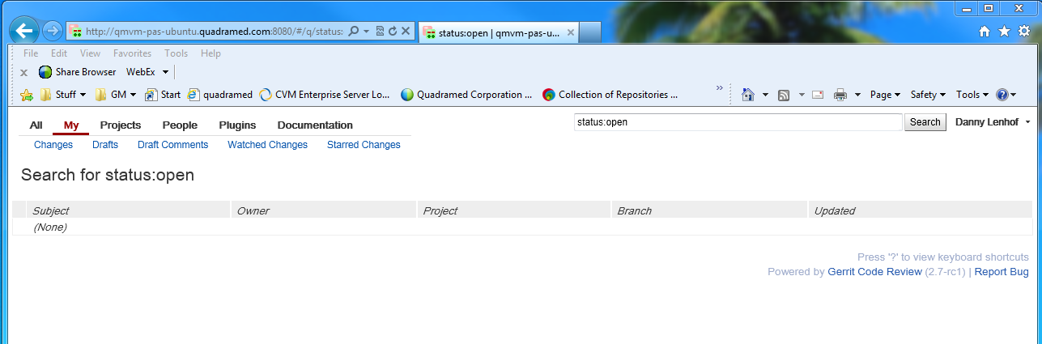

Select Projects and List, project are listed in this view. Leave Gerrit open, you will come back to setup SSH.

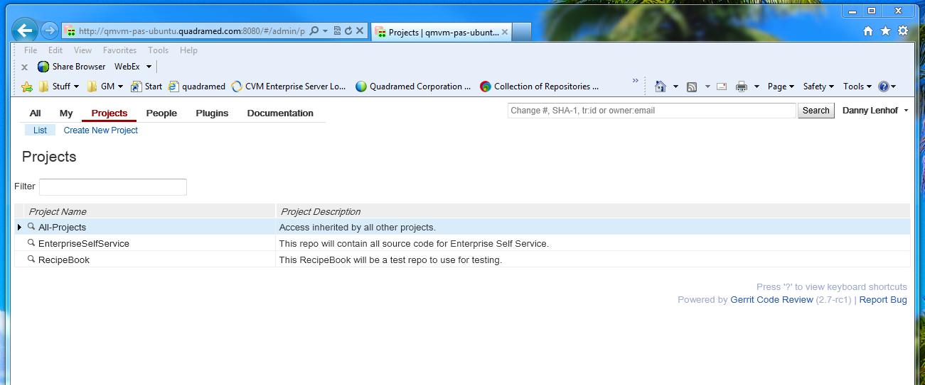

**2) Install TortoiseGit**

Supported versions of TortoiseGit and msysgit are:

* TortoiseGit 1.8.2.0
  + 32-bit - <http://code.google.com/p/tortoisegit/downloads/detail?name=TortoiseGit-1.8.2.0-32bit.msi&can=1&q>=
  + 64 bit - <http://code.google.com/p/tortoisegit/downloads/detail?name=TortoiseGit-1.8.2.0-64bit.msi&can=1&q>=
* git version 1.8.1.msysgit.1 (C:\Program Files (x86)\Git\bin) –
  + <http://code.google.com/p/msysgit/downloads/detail?name=Git-1.8.1.2-preview20130201.exe&can=2&q>=

Add user information, Open Git>Settings. Select Git and

1. Add your name in the text box as First.Last. Reference screenshot below.
2. Add your e-mail. This is case sensitive – check in outlook for the correct case.
   1. Example differences
      1. [danny.lenhof@quadramed.com](mailto:danny.lenhof@quadramed.com) (lowercase)
      2. [Santhosh.Grandai@quadramed.com](mailto:Santhosh.Grandai@quadramed.com) (uppercase)
      3. [pavan.duggirala@quadramed.com](mailto:pavan.duggirala@quadramed.com) (lowercase)

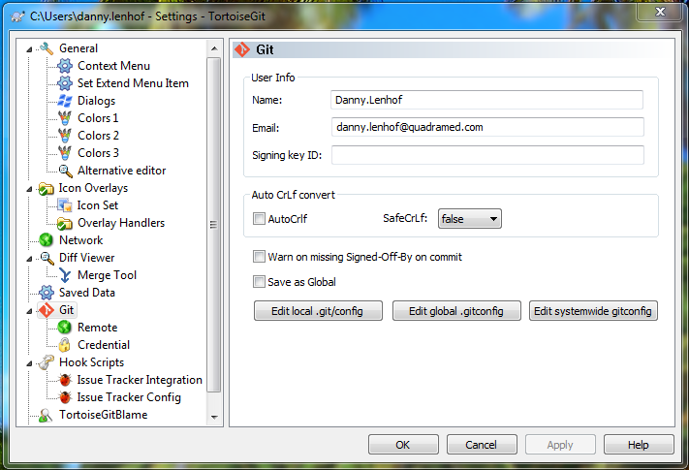

1. Click OK when done.
2. **Git setup with TortoiseGit**

To connect to an existing Git repository, you will need to generate an SSH key file. The installer for TortoiseGit also installs PuTTY Key Generator.

This is found in Start>All Programs>TortoiseGit.

Run the PuTTY Key Generator.

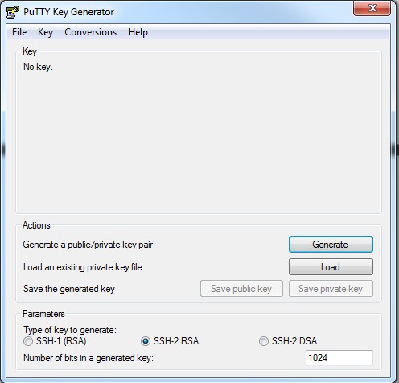

Click “Generate”. Move your mouse in the gray area.

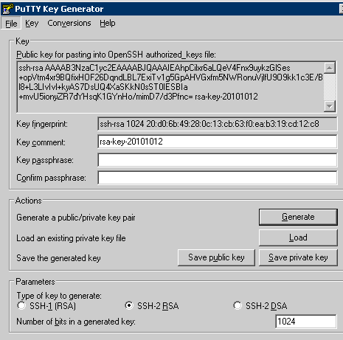

Stop here – DO NOT click the Save private key – read next step before continuing..

Copy the public key temporarily into Notepad for later, we will copy this into Gerrit. This is presented in the screenshot above starting with ss-rsa to the end where it shows the rsa-key-date.

Click “Save private key” and save the key file to the hard drive. I placed this in my C:\Users\first.lastname\.ssh folder. TortoiseGit will prompt you for this when you use TortoiseGit to clone the Git repository.

**4) Copy the SSH Public Key into Gerrit**

In Gerrit, click your name and click settings.

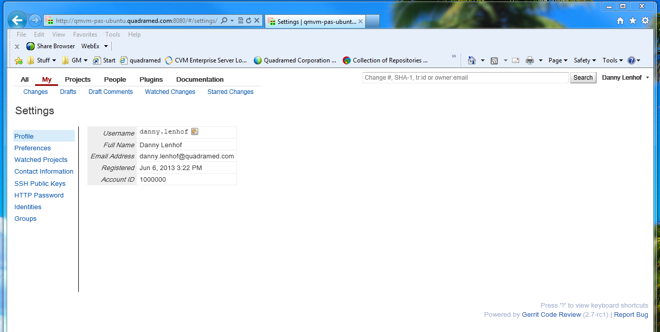

On the left side Click SSH Public Keys

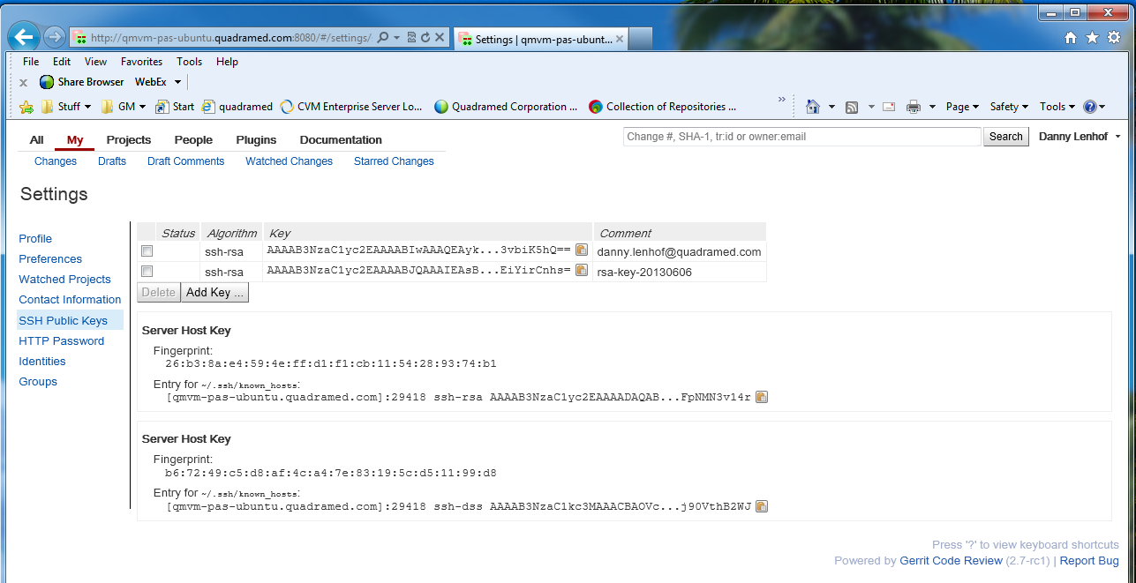

Click Add Key button. Copy the key from Notepad and paste into the Add SSH Public Key text box. After paste, Click the add button.

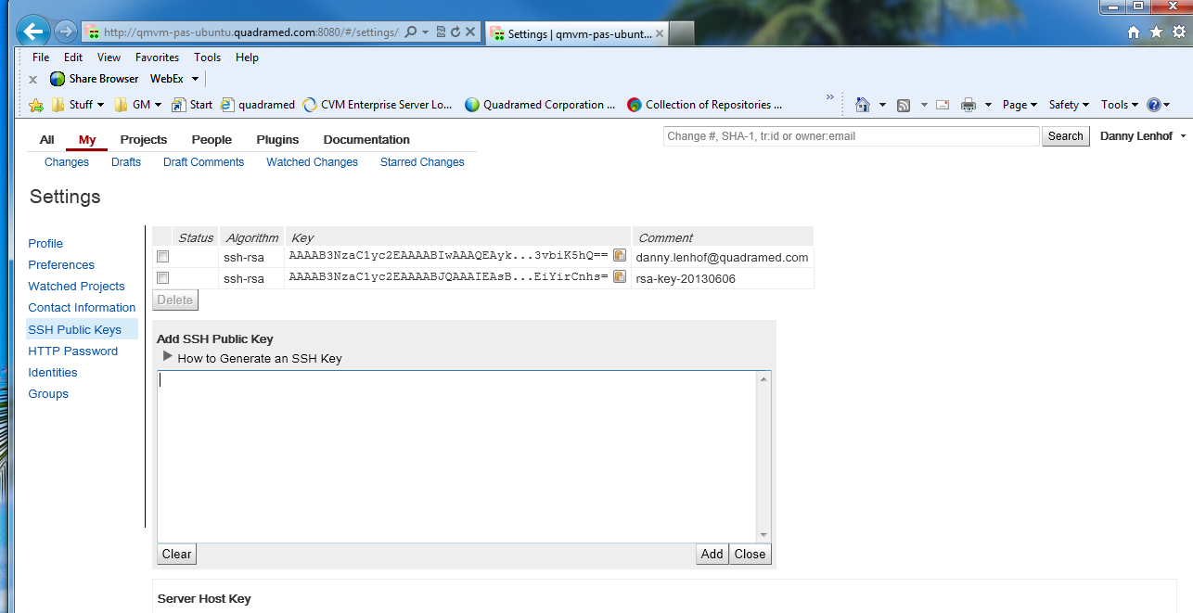

**5) Use TortoiseGit to clone project from Git repository**

Create a workspace on your local machine to host the Git local repos. I created c:\gitProjects\

Open windows explorer to your created workspace.

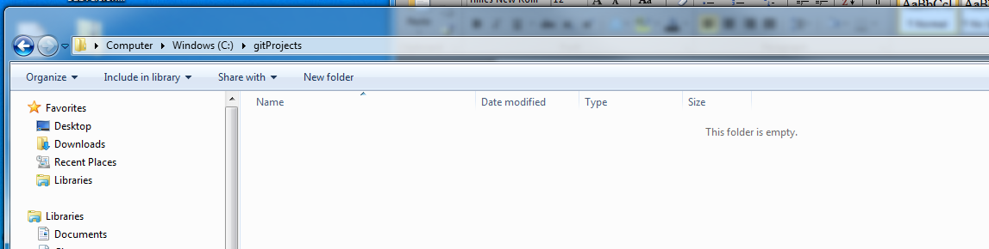

Use TortoiseGit to run the git clone command. The “git clone” command creates a local copy of a remote repository.

In Windows Explorer, right-click your root project folder and click “Git Clone…”.

[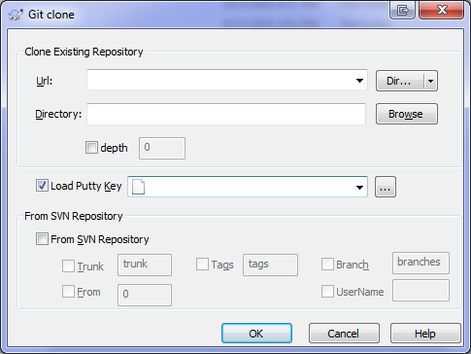](http://www.trishrempel.com/wp-content/uploads/2010/10/tortoisegit_clone.png)

The URL of the remote repository. This will be the SSH found in Gerrit.  
Example: ssh://{first}.{lastname}@qmvm-pas-ubuntu.quadramed.com:29418/RecipeBook

In Gerrit, Select Projects>List>RecipeBook>SSH. Just under SSH Header you will see a line similar to my example above. Copy starting at the SSH to the end of the line and copy to your clipboard.

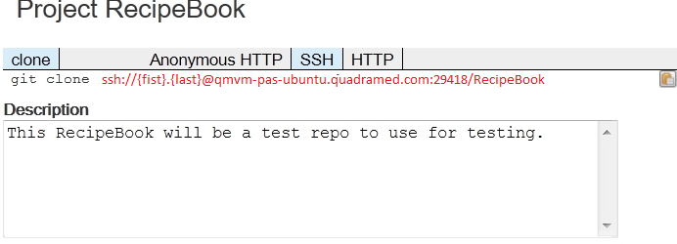

Paste this into the URL text box.

Directory: Paste your workspace location or browse to your workspace location. My example is c:\gitProjects\RecipeBook

Load Putty Key: Select the private Putty key that you saved earlier.

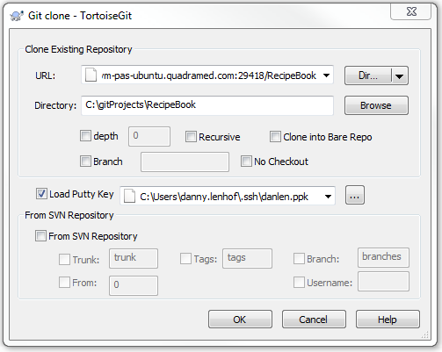

Click OK. The git project source is successfully cloned to your local system.

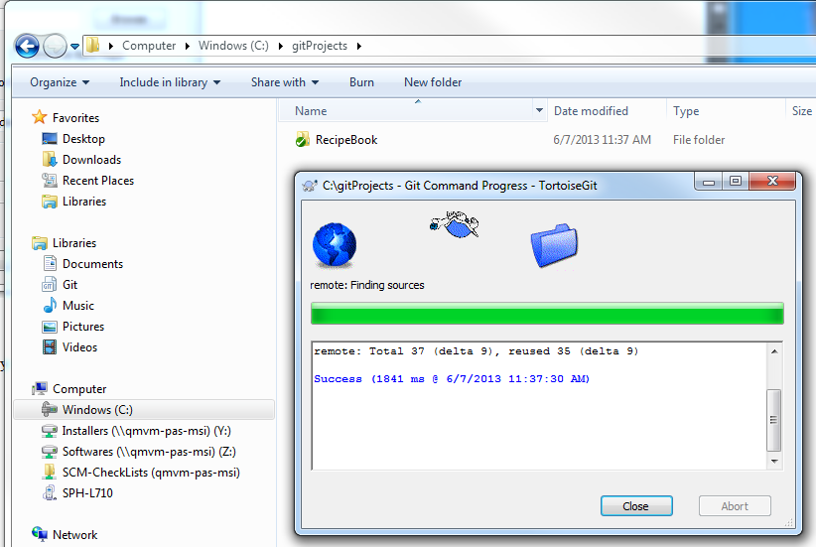

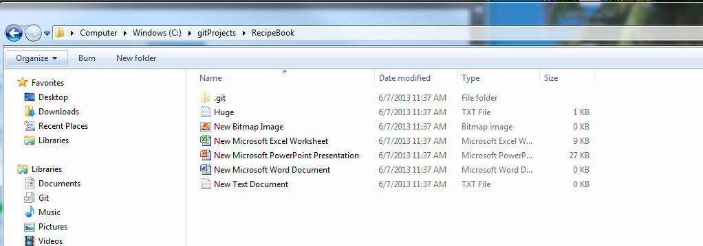

**6) From the command-line**

To use the command line options upload the contents of your *.pub file to Gerrit. Most everyone generated keys a month ago. Use this same key pair found in C:\Users\firstname.lastname\.ssh\ directory. Each of you should have the yourlastname.pub (publickey).

1. Open the yourlastname.pub (publickey) and copy the contents
2. Login to Gerrit
3. Under your name is a pull-down, Select ‘Settings’
4. Select ‘SSH Public Keys’ link
5. Select ‘Add Key …’ Button
6. Copy and Paste the contents of the yourlastname.pub (publickey)
7. Click ‘Add’ button.
8. Logout of Gerrit.

Open Command window on your local machine.

Your workspace > git clone ssh://firstname.lastname@qmvm-pas-ubuntu.quadramed.com:29418/RecipeBook c:\gitProjects\RecipeBook

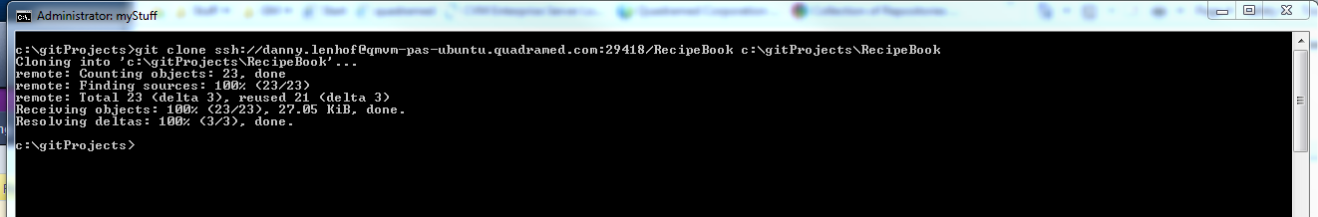

Open windows explorer to your workspace.

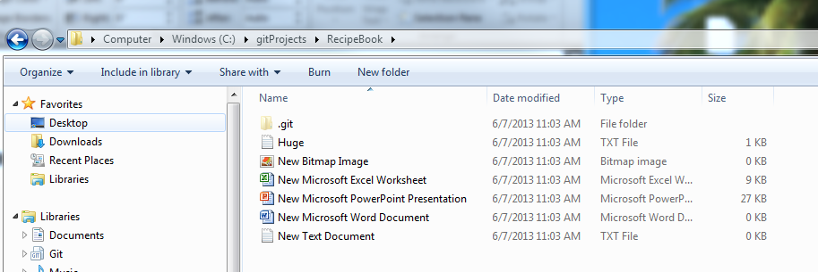

Modify a file.

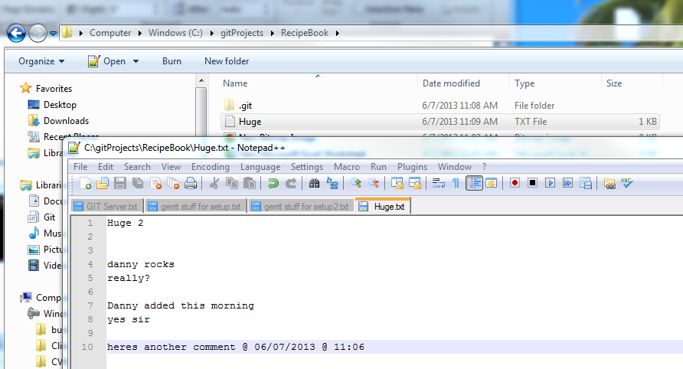

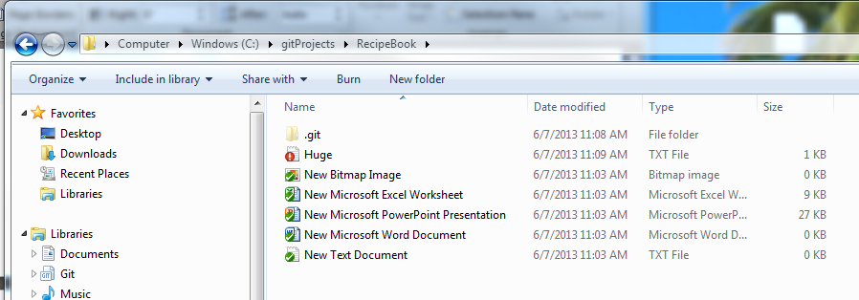

Commit the file. Push the file.

Your workspace > git add .  
Your workspace > git commit –m:”<yourmessage>”  
Your workspace > git push origin master  
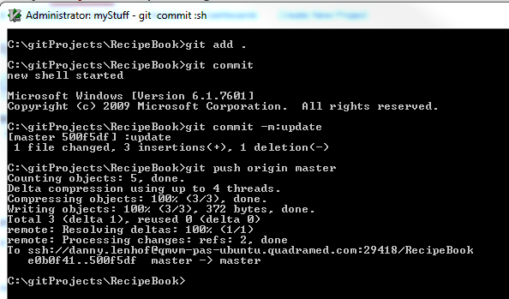

All done. Now others can get your change.